EVENT FORM

Project title | Development of master curricula for natural disasters risk management in Western Balkan countries
Project acronym | NatRisk
Project reference number | 573806-EPP-1-2016-1-RS-EPPKA2-CBHE-JP
Coordinator | University of Nis
Project start date | October 15, 2016
Project duration | 36 months

Project number: 573806-EPP-1-2016-1-RS-EPPKA2-CBHE-JP

"This project has been funded with support from the European Commission. This publication reflects the views only of the author, and the Commission cannot be held responsible for any use which may be made of the information contained therein"

EVENT DESCRIPTION

Date | 07 September 2019
Author | Milan Gocic
Institution | University of Nis
Event title | Sixth Steering Committee, Project Management Committee and Quality Assurance Committee meetings (September 05-06, 2019)

Event description:
University of Sarajevo, Bosnia and Herzegovina (UNSA) organized the sixth Steering Committee, Project Management Committee and Quality Assurance Committee meetings, September 05-06, 2019. Meetings covered wide spectra of very important topics for the future project realization. The meetings were concluded with positive impressions and it was everyone's opinion that it was very beneficial and that detailed and precise instructions were given for the forthcoming activities.

Attachment

Photos (jpg) | Photo
Other personal remarks
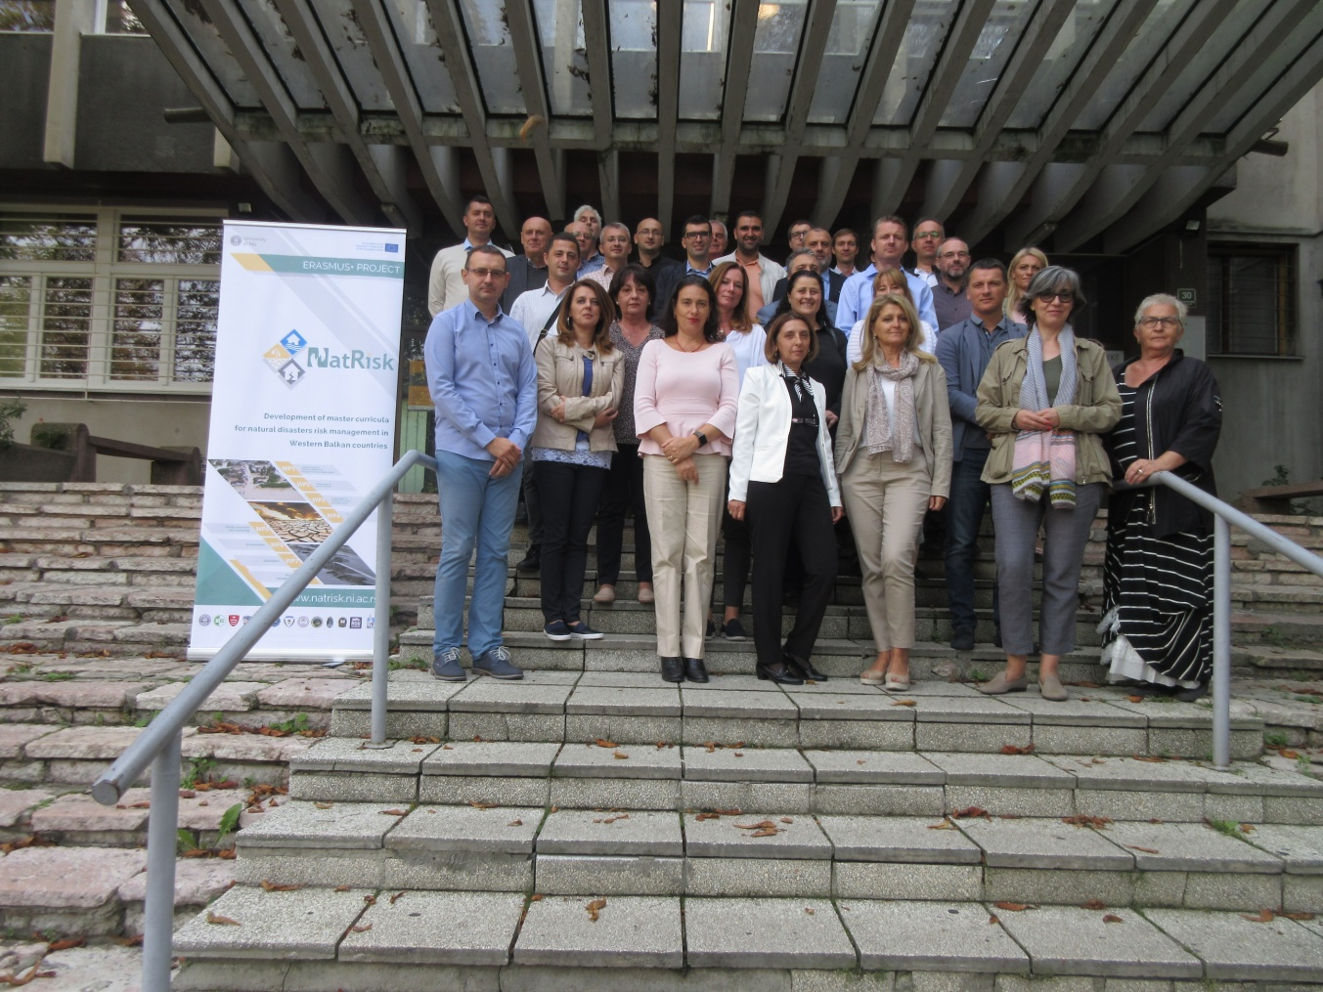

Location, date Signature
Sarajevo, 07 September 2019 ____________________

This template has to be filled by NatRisk project partners for informaing about promotional events to the coordinator, on e-mail address: natriskuni@gmail.com.

